
MATHEMATICS DEPARTMENT
Year 11 Specialist – 2016
Test Number 1: Basic Vectors
Resource Free Section

Whole test:
/ 47
Weight: 3.5%
Name: _______________________________________ Teacher: DDA
Marks: 31
Time Allowed: 30 minutes
Instructions: You ARE NOT permitted any notes or calculator. Show your working where appropriate remembering you must show working for questions worth more than 2 marks.
_________________________________________________________________________
1 Which of the following best describes the direction of the position vector of Q(–3, 7)?
A 113°
B –113°
C 203°
D 67°
E 337°
[1 mark]
2 Calculate the resultant of the forces shown below.
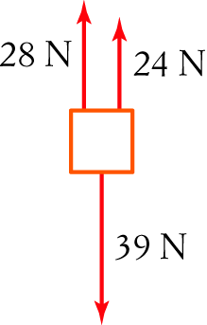
A 39 N down
B 91 N
C 52 N up
D 13 N up
E 13 N down
[1 mark]
3 This diagram shows vectors a, b and a third vector. Which of the following best describes the third vector?
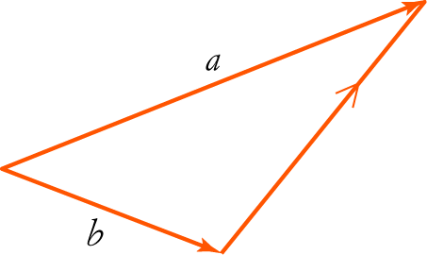
A a + b
B a + –b
C b + a
D b – a
[1 mark]
4 If m = i – 6j, which of the following vectors is opposite in direction to m?
A –6i + j
B (–2, –12)
C (–2, 12)
D
E 6i – j

[1 mark]
5 This diagram shows vectors g and d. Which of the following best represents the resultant of g and d?
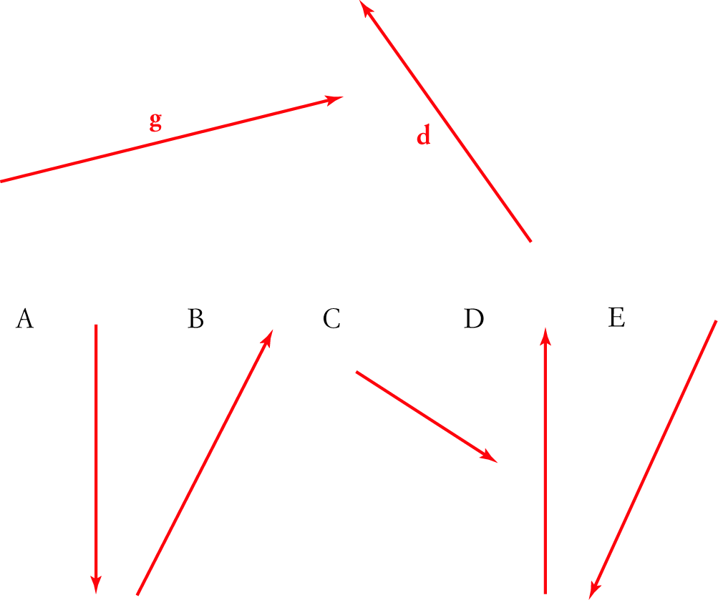

[1 mark]
6 Which of the following is orthogonal with (perpendicular to) n = (1, –1)?
A 2i + 2j
B (2, –1)
C –5i + 2j
D (–2, 2)
E (–4, 3)

[1 mark]
7 Write the following vectors in polar form.

a A vector a of magnitude 5 in the positive direction of the y-axis ___________

b A vector b with norm 7 in the negative direction of the x-axis ___________

c A vector c of magnitude 10 in a direction 135° anti-clockwise from the x-axis ___________

[3 marks]
8 Convert the vector to polar form. ____________
[1 mark]
9 Find the norm of the vector (7, –24). ____________

[1 mark]

10 Sketch each of the following vectors. (Clearly label all relevant parts of your sketch.)
a (–6, 9) b (3, 300°)
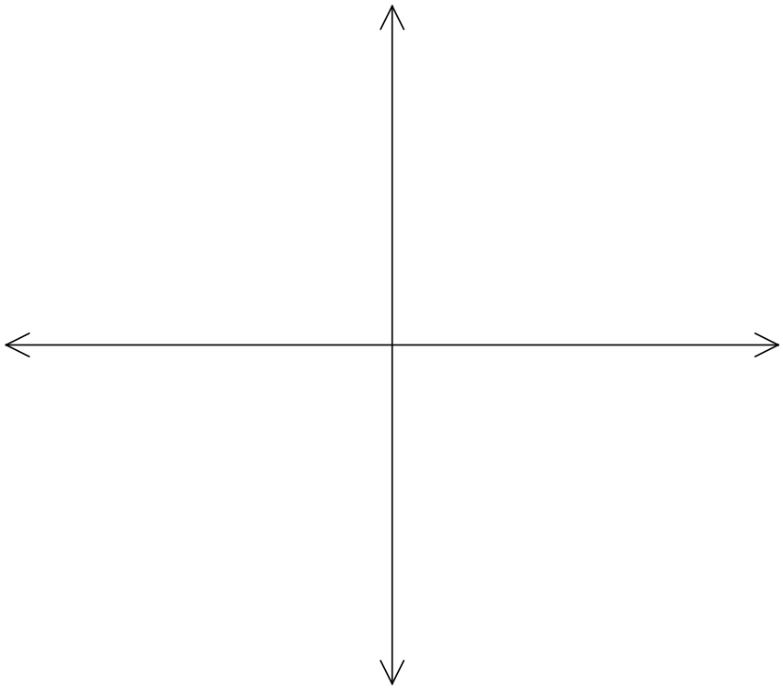

[2 marks]
11 Given b = (2, 7), d = (8, –2) and e = (–4, –2), find:

a 5e _______________________

b 6d – 4b

[2 marks]
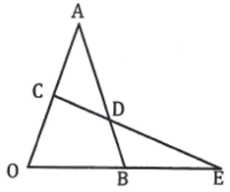
12 OAB is a triangle with C the mid-point of OA and D
a point of AB such that AD is two thirds of AB.
CD continued meets OB continued at E.

If $\vec{OA}=a$ and $\vec{OB}=b$ express each of the following in terms of $a$ and/or $b$.

- $\vec{OC}$ __________________
- $\vec{AB}$ __________________
- $\vec{AD}$ __________________
- $\vec{CD}$ ________________________________________________________________
- If $\vec{CE}=h\vec{CD}$ and $\vec{OE}=k\vec{OB}$ use the fact that $\vec{OC}+\vec{CE}=\vec{OE}$ to determine $h$ and $k$.

[1,1,1,2,3: 8 marks]
13 Write as a linear combination of i and j. __________________

[1 mark]
14 Find the displacement vector for the following movement.
Q(–2, –5) to P(–5, 4)

[1 mark]
15 Using the component form of geometric vectors, complete the following proof for the associative law of vector addition. $\left(a+b\right)+c=a+(b+c)$

Let $a=\left(\begin{matrix}x_{1} \\ y_{1}\end{matrix}\right), b= , c=$
RTP:
Proof: LHS =
=
=
=
=
= RHS

[3 marks]
16 Without changing her speed, a speed skater travelling at 27 m/s changes direction by 60°. What is her change in velocity?


[3 marks]


MATHEMATICS DEPARTMENT
Year 11 Specialist – 2016
Test Number 1: Basic Vectors
Resource Rich Section
Name: _______________________________________ Teacher: __________________
Marks: 16
Time Allowed: 15 minutes
Instructions: You ARE allowed 1 page of notes (both sides) and a CAS calculator.
You must show your working to receive full marks whenever a question is worth more than 2 marks. Where relevant, and unless otherwise, specified give answers to 2 decimal places.
_________________________________________________________________________
17 Convert the vector (17.5, 161°) to component form.

____________________________________________
[1 mark]
18 Convert the vector (5,1) to polar form.

____________________________________________
[1 mark]
19 Find the norm of the vector .

____________________________________________
1 mark]
20 Write (16, 217°) as a linear combination of i and j.

____________________________________________

[1 mark]

21 Given y = (22, 342°) and z = (15, 72°) , find y + z without changing to component form.

[4 marks]
22 Given g = (18, 144°) and m = (30, 225°), find g – m. Give your answer in polar form.

[2 marks]

23 A boat travels 19 nautical miles in a direction N 30° E and then travels 25 nautical miles south-east.
Express each of these displacements in component form (east and north) and hence find the displacement for the whole journey in polar form. Give positive polar angle.

[6 marks]

